Below are indicators of child abuse and neglect, please note that the signs in each category may pertain to one or more types of abuse or neglect. If you suspect abuse, please call the Tennessee toll free Child Abuse Hotline at 1-877-237-0004.
Signs of  Sex Abuse |  | Signs for Sexual  Exploitation of Minors
- Soreness or bruising, pain or itching in genital or anal areas  - Sexually transmitted diseases  - Nightmares or bedwetting  - Unexplained loss of appetite  - Becoming isolated or withdrawn  - Excessive masturbation or sexual play  - Abuses children, animals or pets  - Attaches very quickly to strangers or new adults in their environment  - Obsession with pornography or viewing sexually explicit photos  - Repeated runaway or suicide attempts  - Self-destructive behavior/self-injury/cutting, risky or delinquent behavior  - Substance abuse |  | - History or presence of emotional, sexual, or other physical abuse  - Sexually transmitted diseases  - Evidence of homelessness; no identification and runaway  - Inexplicable appearance of expensive gifts, clothing, or other costly items  - Presence of an older boy-/girlfriend  - Evidence of drug use  - Possesses multiple phones and hotel room cards  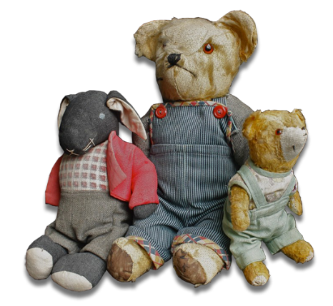  - Repeated statement of urgent  need to leave or get back home

Signs of Physical Abuse
- Unexplained fractures or injures  - Previous injuries in various healing stages  - Patterned injuries consistent with objects of abuse (cigarettes, belt, hands)  - Burns on extremities, buttocks or genitals  - Frightened of or shrink at approach of adult caregiver |  | - Emotional turmoil (anxiety, depressed, suicidal); developmental delays  - Self-isolation or undue aggression  - Fear of going home; many school absences  - Abuses animals or pets
Signs of Emotional Abuse |  | Signs of Neglect
- Anxiety, depression or humility  - Constant belittling, shaming, and humiliation  - Developmental delays; failure to thrive  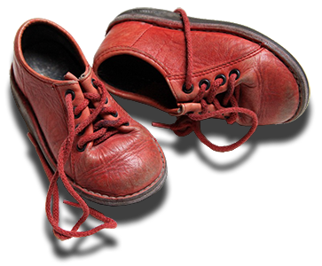 |  | - Abandonment or reports that there is no one at home to provide care  - Constant hunger or begs or steals food for money; signs of malnutrition  - Abuses alcohol or drugs  - Lacks sufficient clothing for the weather or clothes are filthy  - Neglected personal hygiene (body odor, matted hair)  - Consistent lack of supervision  - Untreated medical issues

